Submitted by:
Krish chaudhary
Roll No:HD.SC.U4CSE25013
Course: Object oriented programming
Academic Year: 2025-2026

Submitted to:

Dr .Monika kashyap
Department of Computer science
Amrita vishva vidyapeetham

Smart Parking System

Aim:
To design and implement a fully automated Smart Parking System using IoT hardware and software that detects vehicle presence using infrared sensors, controls entry and exit gates using servo motors, calculates real-time toll charges based on parking duration, registers vehicle numbers through a web interface, and displays all live parking data on a web-based dashboard connected to a Java backend server via MQTT protocol over WiFi.

Theory:

1. Internet of Things (IoT)
The Internet of Things (IoT) refers to a network of physical devices embedded with sensors, software, and communication hardware that enables them to collect and exchange data over the internet without requiring human-to-human or human-to-computer interaction. IoT devices can sense their environment, process information locally or remotely, and trigger automated actions based on predefined logic.
In this project, the ESP32 microcontroller acts as the IoT device. It reads data from five IR sensors, controls two servo motors, a buzzer, and two LEDs, and communicates wirelessly with a remote Java backend server using the MQTT protocol. This makes the entire parking system intelligent and self-operating.

2. ESP32 Microcontroller
The ESP32 is a low-cost, low-power system-on-chip (SoC) microcontroller developed by Espressif Systems. It features a dual-core 32-bit processor running at up to 240 MHz, built-in WiFi (802.11 b/g/n), Bluetooth 4.2, and a large number of GPIO (General Purpose Input/Output) pins. It supports various communication protocols including SPI, I2C, UART, and PWM.
In this project, the ESP32 performs the following functions: reads IR sensor signals through digital input pins, generates PWM signals to control servo motor angles, drives the buzzer and LEDs through digital output pins, connects to the WiFi network automatically on startup, and publishes MQTT messages to the HiveMQ broker whenever a sensor state changes.

3. MQTT Protocol
MQTT (Message Queuing Telemetry Transport) is a lightweight publish-subscribe messaging protocol designed for constrained devices and low-bandwidth, high-latency networks. It was originally developed by IBM and is now an open standard maintained by OASIS. MQTT operates over TCP/IP and uses a broker-based architecture.
In MQTT, devices are classified as publishers or subscribers. A publisher sends messages to a specific topic on the broker. A subscriber registers interest in one or more topics and receives all messages published to those topics. The broker acts as an intermediary that routes messages between publishers and subscribers.
In this project, the ESP32 is the publisher. It publishes slot status, entry events, and exit events to the HiveMQ public broker. The Java backend is the subscriber. It subscribes to all relevant topics and receives the data in real time. This decoupled architecture allows the hardware and software to operate independently and communicate asynchronously.

4. HiveMQ Public Broker
HiveMQ is a professional MQTT broker developed by HiveMQ GmbH. The HiveMQ public broker at broker.hivemq.com provides a free, publicly accessible MQTT broker on port 1883. It requires no account creation or authentication for basic use and supports thousands of simultaneous connections. It is widely used in IoT development and testing environments. In this project, HiveMQ acts as the cloud messaging backbone connecting the ESP32 hardware to the Java backend software.

5. IR (Infrared) Sensor
An IR sensor module consists of an IR transmitter LED and an IR receiver photodiode along with a comparator circuit. The transmitter continuously emits infrared light. When an object comes within the detection range (typically 2 cm to 30 cm), the infrared light reflects off the object and is detected by the receiver. The comparator then outputs a LOW digital signal (logic 0) indicating object detection, and a HIGH signal (logic 1) when no object is present.
In this project, five IR sensors are used. Three are placed at the parking slots to detect whether a vehicle is parked. One is placed at the entry gate and one at the exit gate to detect approaching vehicles and trigger gate control.

6. Servo Motor (MG90S)
The MG90S is a micro servo motor with metal gears capable of rotating up to 180 degrees. It operates on 4.8V to 6V and is controlled using PWM (Pulse Width Modulation) signals. The angle of rotation is determined by the pulse width of the PWM signal. A 1ms pulse corresponds to 0 degrees and a 2ms pulse corresponds to 180 degrees.
In this project, the ESP32Servo library abstracts the PWM generation and allows servo control using simple degree values. The entry gate servo is powered by the ESP32 VIN pin (5V from USB) and connected to D25. The exit gate servo is powered by an Arduino UNO's 5V pin and connected to D33. Both servos rotate to 130 degrees to open the gate and return to 0 degrees to close it.

7. Real-Time Toll Calculation
Toll calculation in this system is time-based. The moment a vehicle occupies a parking slot, the Java backend records the entry time using the System.currentTimeMillis() method which returns the current time in milliseconds since the Unix epoch. The toll is calculated using the formula: Toll = (Elapsed Time in milliseconds / 10000) x 5, which gives Rs 5 for every 10 seconds the vehicle remains parked. The toll is recalculated on every dashboard refresh which occurs every 2 seconds, providing a live updating toll counter for each occupied slot.

Hardware Components:

1. ESP32 Development Board (38-pin)
The ESP32 is the brain of this project. It runs the main Arduino sketch that initializes all pins, connects to WiFi, establishes the MQTT connection, and continuously reads all sensor states in the loop function. When a sensor state changes, it triggers the appropriate action such as opening a gate or publishing an MQTT message. It operates at 3.3V logic level and is powered via a Micro USB cable connected to a laptop. The VIN pin provides 5V output when powered via USB, which is used to power the entry gate servo motor.

2. IR Sensor Modules (5 units)
Five IR obstacle detection sensor modules are used. Each module has three pins: VCC (3.3V power), GND (ground), and OUT (digital output signal). The sensor modules are powered from the 3.3V rail on the breadboard. The OUT pin of each sensor is connected to a designated digital input pin on the ESP32. All five sensors operate identically but serve different roles: three monitor parking slots and two monitor the entry and exit gates.

3. MG90S Servo Motors (2 units)
Two MG90S servo motors are used as physical gate barriers. Each servo has three wires: brown (GND), red (VCC power), and orange (signal/PWM). The entry gate servo is powered from the ESP32 VIN pin (5V) and receives its PWM signal from D25. The exit gate servo is powered from the Arduino UNO's 5V pin since the ESP32 VIN cannot safely power two servos simultaneously, and receives its PWM signal from D33. Both servos share a common ground through the breadboard's blue GND rail.

4. Green LED and Red LED
Two 5mm LEDs are used as visual status indicators at the entry gate. The green LED lights up when the entry gate opens to signal that the car is welcome to enter. The red LED lights up when the gate is closed to signal that entry is not currently permitted. Both LEDs are connected through 220-ohm current limiting resistors to prevent excess current from damaging the LEDs or the ESP32 GPIO pins. The green LED is connected to D18 and the red LED to D19.

5. Buzzer
An active piezoelectric buzzer is used to provide an audible alert when a car is detected at the entry gate. An active buzzer produces sound when a DC voltage is applied directly without requiring an external oscillator circuit. The buzzer is connected to D5 on the ESP32. When the entry IR sensor detects a vehicle, the ESP32 sets D5 HIGH for 300 milliseconds producing a short beep, then sets it LOW again.

6. Arduino UNO
The Arduino UNO is not programmed in this project. It serves purely as a regulated 5V power supply for the exit gate servo motor. The Arduino's 5V and GND pins are connected directly to the servo's red and brown wires. The Arduino's GND is also connected to the ESP32's common GND rail on the breadboard to ensure a shared reference voltage for the servo signal coming from the ESP32. The Arduino is powered via a separate USB cable connected to a PC.

7. Resistors (220 Ohm)
Two 220-ohm resistors are used as current limiting components for the green and red LEDs. Without resistors, the LEDs would draw excessive current from the ESP32 GPIO pins which can only safely source 12mA per pin. The 220-ohm resistor limits the LED current to approximately 10mA at 3.3V logic level, which is within the safe operating range and still provides adequate brightness.

ESP32 Pin Configuration:

Component | ESP32 Pin | Type
Entry Gate Servo Motor | D25 | PWM Output
Exit Gate Servo Motor | D33 | PWM Output
Entry Gate IR Sensor OUT | D27 | Digital Input
Exit Gate IR Sensor OUT | D26 | Digital Input
Slot 1 IR Sensor OUT | D34 | Digital Input (Input Only)
Slot 2 IR Sensor OUT | D35 | Digital Input (Input Only)
Slot 3 IR Sensor OUT | D14 | Digital Input
Green LED (via 220 ohm resistor) | D18 | Digital Output
Red LED (via 220 ohm resistor) | D19 | Digital Output
Buzzer | D5 | Digital Output
3.3V to Red Power Rail | 3V3 | Power Output
GND to Blue Ground Rail | GND | Common Ground
Entry Servo Power | VIN | 5V Power Output

Software Components:

1. Arduino Libraries Used

Library | Purpose
WiFi.h | Built-in ESP32 library for WiFi connectivity
PubSubClient | MQTT client for publishing and subscribing to topics
ESP32Servo | Controls servo motors using PWM on ESP32 GPIO pins
ArduinoJson | Creates and parses JSON formatted MQTT message payloads

2. Java Files and Their Roles

The Java backend consists of five source files each serving a distinct purpose in the system architecture:

Main.java — This is the entry point of the Java application. When executed, it creates an instance of ParkingMqttClient and calls its connect() method to establish the MQTT broker connection. It then creates an instance of ParkingHttpServer on port 8080 and starts it. Finally it keeps the main thread alive using Thread.currentThread().join() so the application continues running indefinitely.

ParkingMqttClient.java — This file handles all MQTT communication. It connects to broker.hivemq.com using the Eclipse Paho MQTT client library with a unique client ID generated using the current timestamp. It subscribes to four topics: smartparking/slots for slot occupancy updates, smartparking/entry for entry gate events, smartparking/exit for exit gate events, and smartparking/vehicle for vehicle number registration. The messageArrived() callback method is triggered automatically whenever a message arrives on any subscribed topic. It parses the JSON payload using Gson and delegates processing to ParkingManager. It also manages gate open/close status by starting a background thread that automatically resets the gate status to closed after 6 seconds.

ParkingManager.java — This is the core data management class. It maintains a map of three ParkingSlot objects identified by slot1, slot2, and slot3. The updateSlotStatus() method is called when a slot status message arrives. If a slot transitions from free to occupied, it assigns the pending vehicle number and records the entry time. If a slot transitions from occupied to free, it saves the vehicle name and parking duration before calling carLeft() to prevent data loss, calculates the final toll, adds the total to earnings, and creates a TollRecord for the history. The getFullStatus() method builds a complete data map that is serialized to JSON and sent to the dashboard.

ParkingSlot.java — This class models an individual parking slot. Each slot stores its slot ID, occupancy status, entry time in milliseconds, vehicle number, and the toll rate constant of Rs 5 per 10 seconds. The carParked() method records the entry time and vehicle number. The carLeft() method calculates and returns the total toll then resets all fields. The calculateCurrentToll() method computes the live toll by dividing elapsed milliseconds by 10000 and multiplying by the rate, giving a continuously increasing toll amount.

ParkingHttpServer.java — This file uses Java's built-in com.sun.net.httpserver package to run a lightweight HTTP server on port 8080. It exposes three REST API endpoints. The GET /api/status endpoint returns the full parking status as JSON including all slot data, earnings, toll history, and gate statuses. The POST /api/vehicle endpoint accepts a JSON body with a vehicleNumber field and passes it to ParkingManager for pre-registration before the car arrives. The GET /api/toll endpoint returns only the toll history records. CORS headers are added to all responses to allow the HTML dashboard running as a local file to make cross-origin requests.

3. Dashboard (index.html)
The web dashboard is a single HTML file that uses JavaScript to fetch data from the Java backend's HTTP API every 2 seconds using the Fetch API. It displays a live statistics row showing total slots, free slots, occupied slots, and total earnings. The main parking grid shows each slot as a card with color coding — green border for free and red border for occupied — along with the vehicle number, parking duration formatted in minutes and seconds, and the current toll amount. A gate status section shows entry and exit gate icons that change from red to green when a gate opens. A vehicle registration panel allows the operator to enter a vehicle number before the car arrives. A toll history table at the bottom shows all completed parking records in reverse chronological order with vehicle number, slot, duration, toll amount, and exit time.

Block Diagram / System Architecture:

[ System Architecture Block Diagram ]
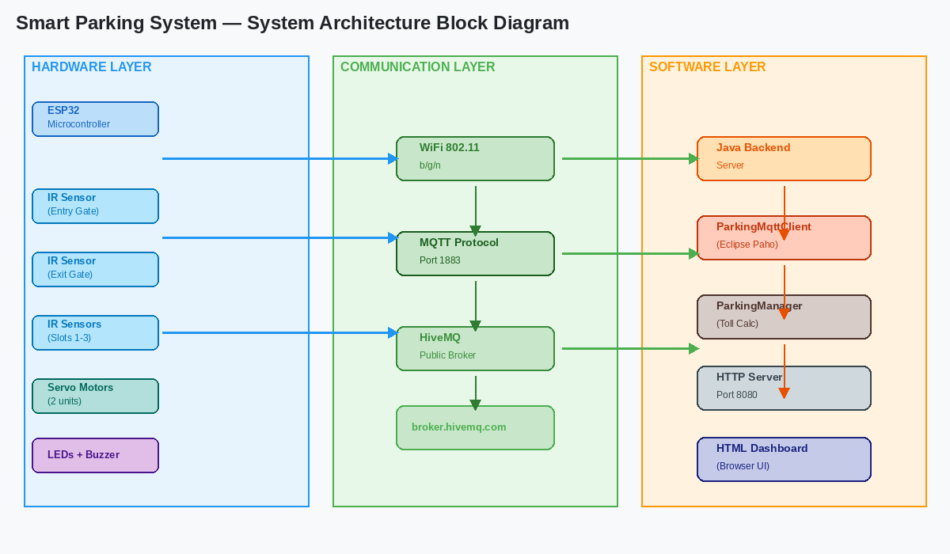
Fig 1: Block Diagram showing complete system architecture from sensors to dashboard

The system is organized into three layers. The Hardware Layer consists of the ESP32, five IR sensors, two servo motors, two LEDs, and a buzzer. The Communication Layer uses the MQTT protocol over WiFi through the HiveMQ public cloud broker to connect the hardware to the software. The Software Layer consists of the Java backend which processes data and calculates toll, and the HTML dashboard which displays everything to the user.

Data flows in one direction from hardware to software for sensor data and toll calculation. The dashboard communicates with the Java backend through a local HTTP REST API. The operator interacts only with the dashboard to register vehicle numbers. All gate control and sensor reading is fully automated by the ESP32.

Procedure:
- Assemble the hardware circuit on the breadboard by connecting the ESP32, five IR sensors, two servo motors, two LEDs with 220-ohm resistors, and a buzzer to their respective ESP32 pins as per the pin configuration table.
- Connect the entry gate servo red wire to the ESP32 VIN row for 5V power and the exit gate servo red wire to the Arduino 5V pin.
- Connect Arduino GND to the common blue GND rail on the breadboard to establish a shared ground reference for the servo signal.
- Install the required Arduino libraries: ESP32Servo, PubSubClient, and ArduinoJson via Tools → Manage Libraries in Arduino IDE.
- Open the smart_parking.ino file in Arduino IDE. Select ESP32 Dev Module as the board and the correct COM port under Tools.
- Temporarily disconnect the wires at D34 and D35 pins to avoid flash communication interference, then upload the code by clicking Upload and holding the BOOT button on the ESP32 when Connecting appears.
- After successful upload, reconnect the D34 and D35 wires and press the EN button on the ESP32 to restart the program.
- Power the Arduino UNO separately via a USB cable connected to a PC to supply 5V to the exit gate servo.
- Verify the ESP32 connects to the WiFi network by opening Serial Monitor at 115200 baud and checking for the WiFi connected message.
- Navigate to the Java backend folder in Command Prompt and run mvn clean package to build the project and download dependencies.
- Run the backend by executing java -jar target/smart-parking.jar and verify the MQTT broker connection and HTTP server messages appear in the console.
- Open the dashboard/index.html file in any web browser. The dashboard should show System Online status and display all three slots as free.
- Enter a vehicle number in the Vehicle Entry panel on the dashboard and click Register Vehicle before the test car approaches the entry sensor.
- Place an object in front of the entry gate IR sensor to simulate a car arriving. The entry gate servo should open to 130 degrees, the green LED should turn on, and the buzzer should beep once.
- Remove the object from the entry sensor and the gate should close automatically and the red LED should turn on.
- Place an object in front of one of the slot IR sensors to simulate parking. The dashboard should show that slot as occupied with the registered vehicle number and start counting the toll.
- Remove the object from the slot sensor to simulate the car leaving. The final toll should be recorded in the toll history table with the vehicle name and duration.
- Test the exit gate by placing an object in front of the exit IR sensor. The exit gate servo should open and close automatically.
- Verify the total earnings update correctly in the statistics row after each car exits.
- End.

Working / System Flow:

Phase 1 — System Initialization
When the ESP32 is powered on, the setup() function executes once. It configures all GPIO pins as inputs or outputs, attaches both servo objects to their respective pins, and sets the initial states: both gates closed at 0 degrees, green LED off, and red LED on. It then calls connectWiFi() which uses the WiFi library to connect to the access point with the configured SSID and password. Once connected, it calls connectMQTT() which establishes a TCP connection to broker.hivemq.com on port 1883 and subscribes to the gate control and vehicle number topics.

Simultaneously, when the Java backend is started, the Main class initializes ParkingManager which creates three ParkingSlot objects. ParkingMqttClient connects to the same HiveMQ broker and subscribes to all four parking topics. ParkingHttpServer starts the HTTP server on port 8080 and registers the three API endpoint handlers.

Phase 2 — Vehicle Entry
The ESP32 loop() function runs continuously. In each iteration it calls handleEntryGateIR() which reads the digital value of D27. When a car approaches the entry gate, the IR sensor output goes LOW. The function detects this falling edge (transition from HIGH to LOW) by comparing the current reading with the stored lastEntryIR value. On detection, openEntryGate() is called which writes 130 to the entry servo causing the gate to rise. greenLEDOn() switches D18 HIGH and D19 LOW. buzzerBeep() sets D5 HIGH for 300ms then LOW. publishEntryEvent() uses ArduinoJson to create a JSON object with an event field set to entry and a timestamp, then publishes it to the smartparking/entry topic via PubSubClient.

The Java backend's ParkingMqttClient receives this MQTT message in the messageArrived() callback. It calls setEntryGateOpen(true) on ParkingManager and starts a background thread that sleeps for 6 seconds and then calls setEntryGateOpen(false), mirroring the physical gate behavior on the dashboard.

Phase 3 — Slot Occupancy Detection and Toll Start
Every 2 seconds, the publishSlotStatus() function in the ESP32 code reads all three slot IR sensor pins (D34, D35, D14) and constructs a JSON object with the status of each slot as either occupied or free. This message is published to the smartparking/slots topic. The Java backend receives it and calls updateSlotStatus() for each slot. When a slot transitions to occupied and was previously free, the ParkingManager calls carParked() on that ParkingSlot which stores the vehicle number from pendingVehicleNumber and records the entry time using System.currentTimeMillis().

From this point, every time the dashboard calls GET /api/status, the ParkingHttpServer calls getFullStatus() on ParkingManager, which in turn calls calculateCurrentToll() on each occupied ParkingSlot. This method computes the elapsed time and applies the Rs 5 per 10 second rate, returning the current toll which is included in the JSON response and displayed on the dashboard.

Phase 4 — Vehicle Exit and Toll Finalization
When the car approaches the exit gate, the exit IR sensor at D26 goes LOW. The handleExitGateIR() function detects this and calls openExitGate() which writes 130 to the exit servo. An MQTT exit event is published to smartparking/exit. After the car passes, the IR sensor returns HIGH and the gate closes automatically after a 1 second delay.

When the slot IR sensor detects the car has left the parking slot, it publishes a free status for that slot. The Java backend receives this and calls updateSlotStatus() with the free status. Since the slot was previously occupied, the manager saves the vehicle name and calculates the final duration before calling carLeft(). A TollRecord object is created with the saved vehicle name, slot ID, total toll amount, and duration in seconds, and added to the tollHistory list. The total earnings counter is incremented. The slot is reset to free and the next vehicle can park.

Phase 5 — Dashboard Live Update
The dashboard JavaScript runs a setInterval() function every 2000 milliseconds that calls fetch('http://localhost:8080/api/status'). The response JSON is parsed and used to update all UI elements: slot card colors and content, statistics counters, gate icons, earnings display, and the toll history table. The dashboard shows system online or disconnected status based on whether the fetch request succeeds or fails, giving the operator a clear indication of backend health.

Hardware and Software Screenshots:

[ Complete Hardware Setup on Breadboard ]
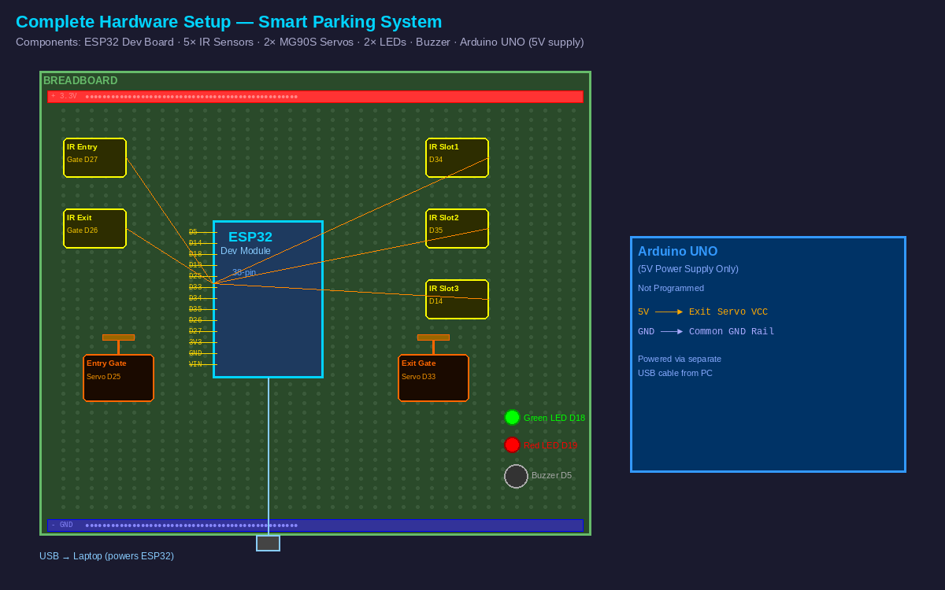
Fig 2: Full hardware assembly showing ESP32, IR sensors, servo motors, LEDs and buzzer

[ Entry Gate with Servo Motor and IR Sensor ]
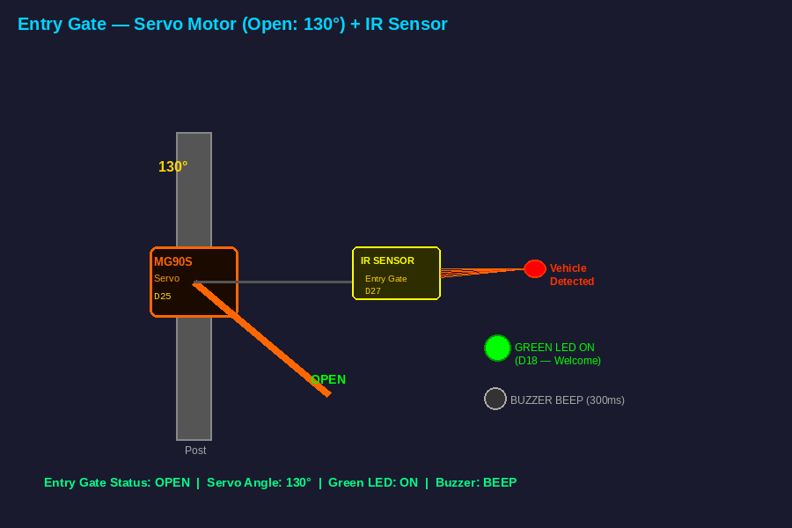
Fig 3: Entry gate servo motor in open position (130 degrees) on vehicle detection

[ Exit Gate with Servo Motor and IR Sensor ]
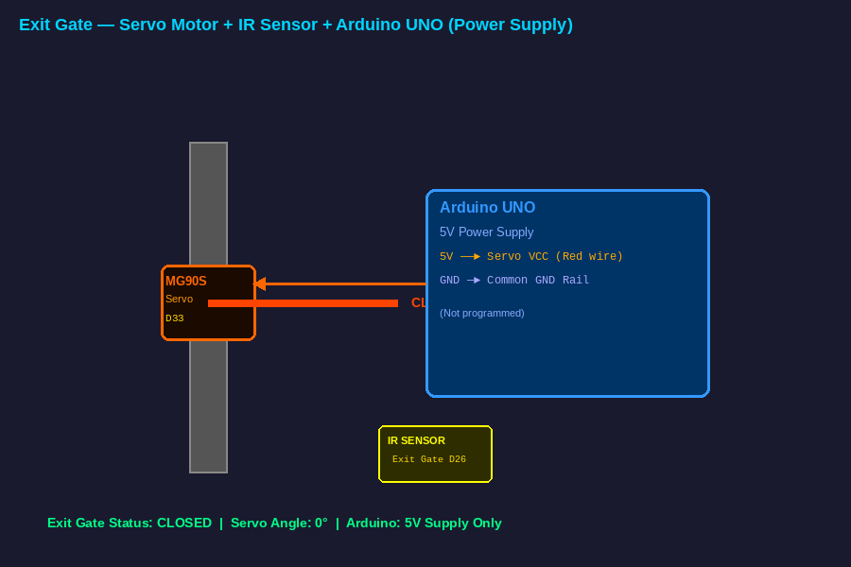
Fig 4: Exit gate servo motor setup

[ Parking Slots with IR Sensors ]
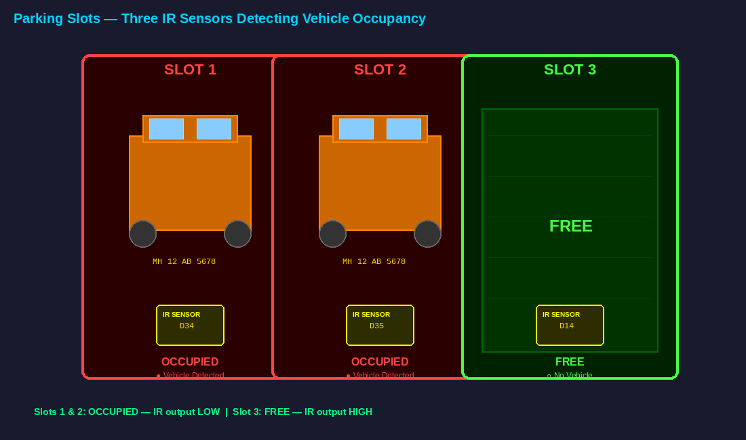
Fig 5: Three parking slot IR sensors detecting vehicle occupancy

[ Dashboard — All Slots Free (System Idle) ]
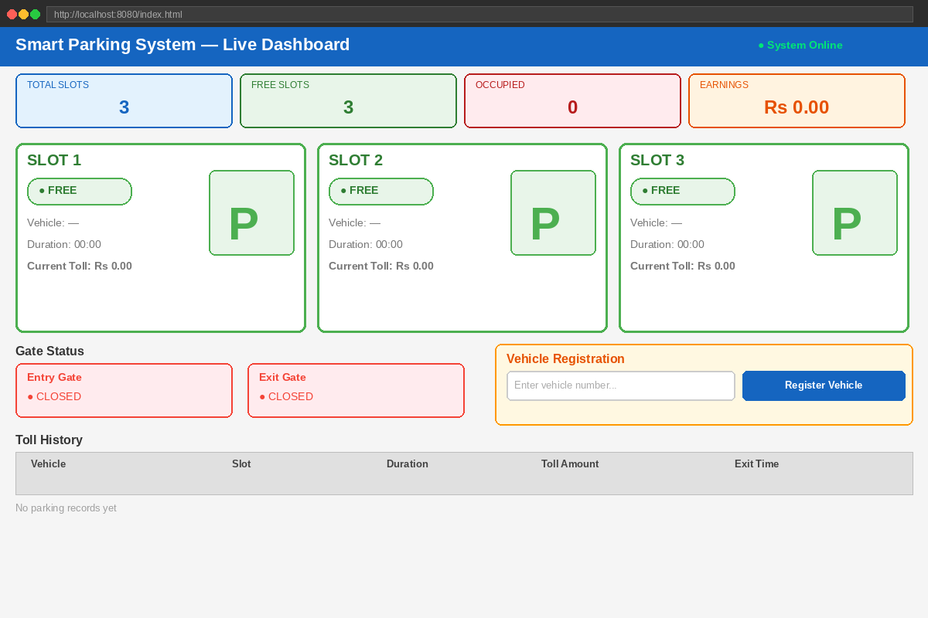
Fig 6: Live Dashboard showing all parking slots free with System Online status

[ Dashboard — Slots Occupied with Live Toll ]
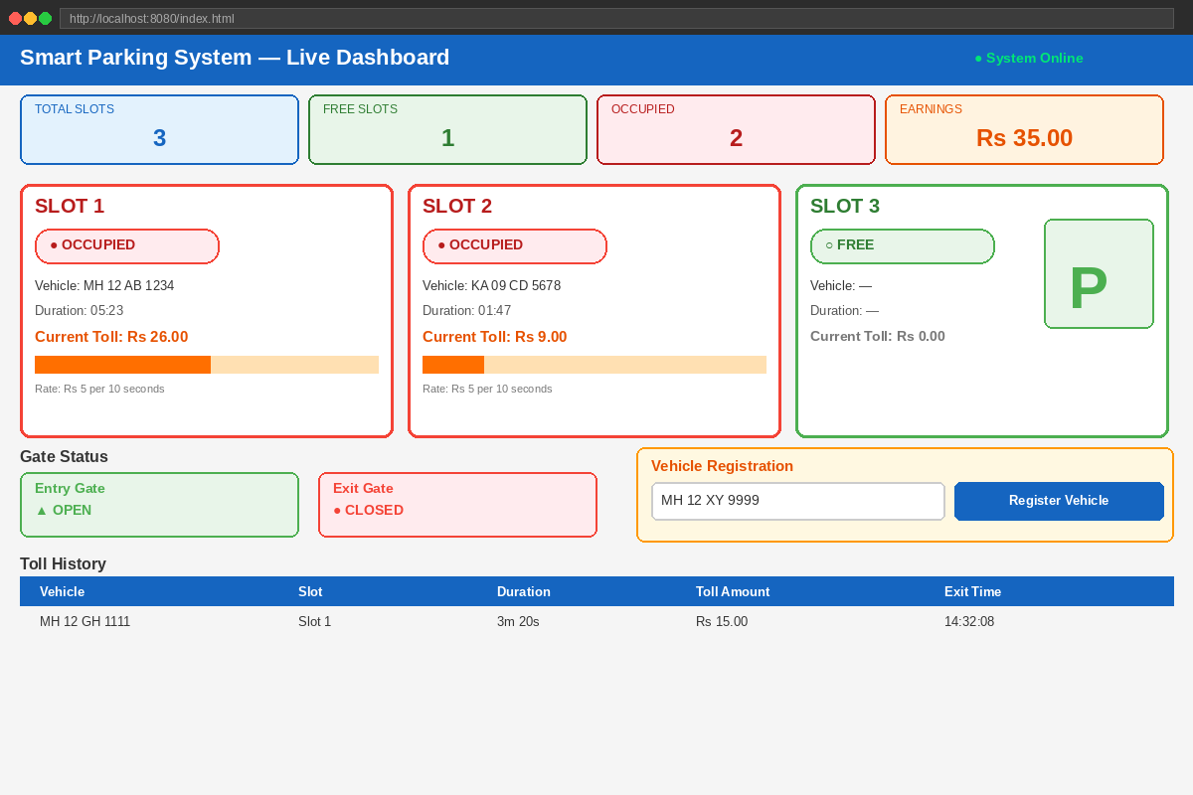
Fig 7: Dashboard showing occupied slots with vehicle numbers and real-time toll amounts

[ Dashboard — Vehicle Registration Panel ]
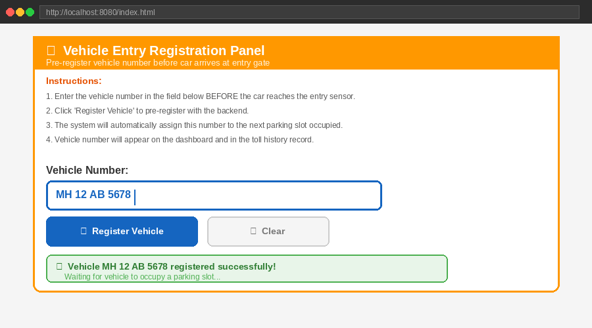
Fig 8: Vehicle number registration panel on dashboard before car arrives

[ Dashboard — Toll History Table ]
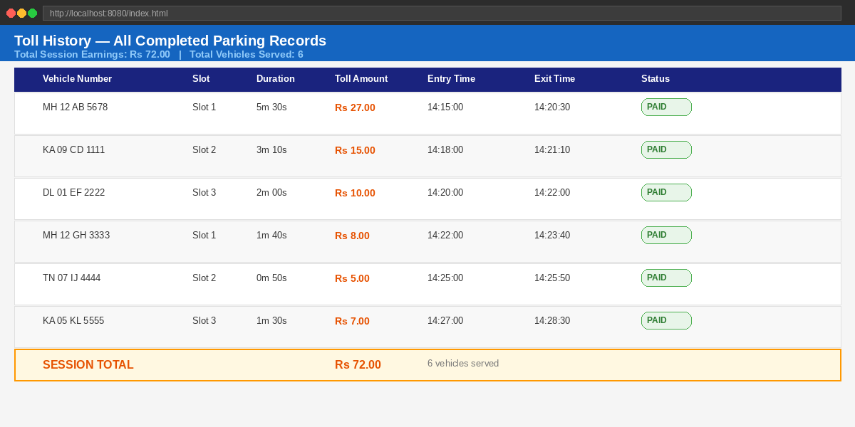
Fig 9: Completed parking records showing vehicle, slot, duration and toll amount

[ Java Backend Running in Command Prompt ]
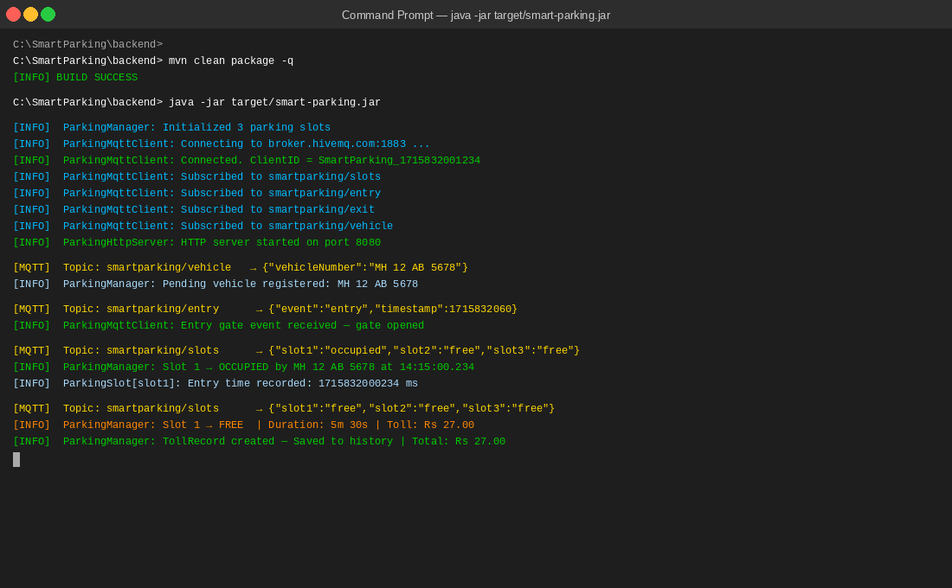
Fig 10: Java backend console showing MQTT messages received and slot status updates

[ Arduino IDE — Successful Code Upload ]
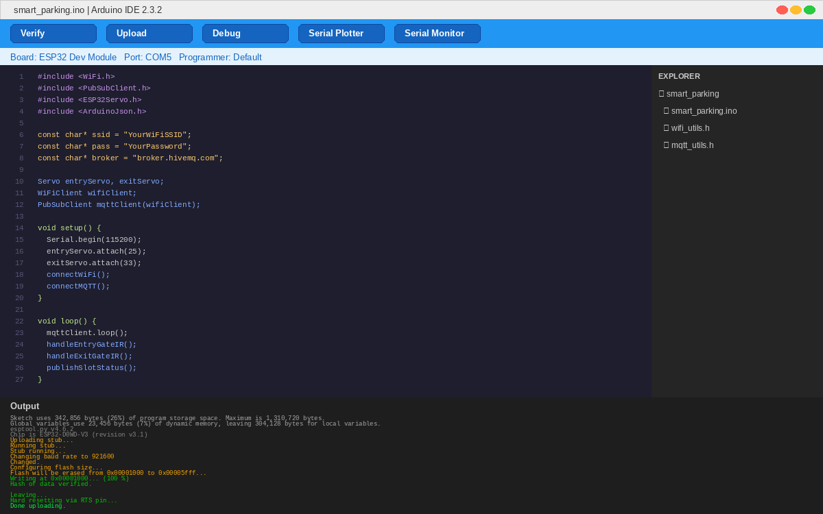
Fig 11: Arduino IDE showing successful upload completion to ESP32

[ Serial Monitor — ESP32 WiFi and MQTT Connection ]
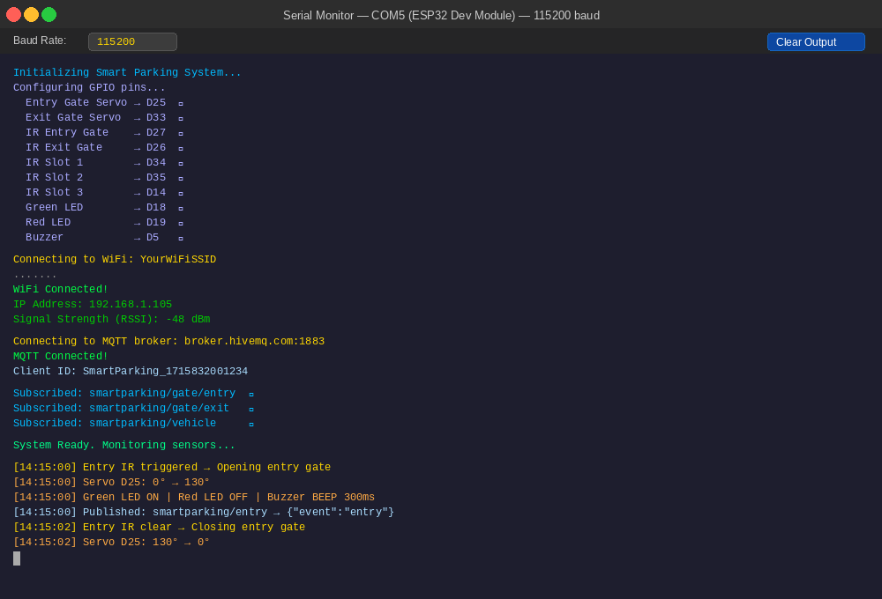
Fig 12: Serial Monitor output showing WiFi connected and MQTT broker connection

Applications:
- Shopping Malls and Multiplex Parking: Automated management of large multi-level parking structures with real-time slot tracking and digital payment integration.
- Airport Parking: Long-term parking management with time-based toll calculation and vehicle number tracking for security purposes.
- Corporate Office Parking: Reserved slot management for employees with automated entry using vehicle number recognition.
- Hospital Parking: Priority-based parking allocation for emergency vehicles with automated gate override capability.
- Smart City Infrastructure: Integration with city-wide traffic management systems to display available parking information on navigation apps.
- University and College Campus Parking: Student and faculty vehicle management with semester-based pass integration.
- Toll Plaza Automation: Highway entry and exit toll collection with automatic vehicle detection and toll calculation without manual collection booths.

Advantages and Limitations:

Advantages:
- Fully Automated: The entire system operates without any human intervention once deployed. Gates open and close automatically, tolls are calculated automatically, and records are maintained automatically.
- Real-Time Monitoring: The web dashboard updates every 2 seconds providing near real-time visibility of all parking slot statuses, vehicle information, and toll amounts from any device with a browser.
- Scalable Architecture: The MQTT publish-subscribe architecture allows the system to be easily expanded to support more parking slots, multiple entry and exit gates, or multiple parking lots by adding sensors and updating the topic structure.
- Low Cost: The entire hardware setup uses inexpensive components including the ESP32, IR sensors, and servo motors, making it affordable for small to medium scale deployment.
- Wireless Communication: No physical wiring is required between the hardware and software layers. WiFi and MQTT provide reliable wireless communication over any network.
- Persistent Records: Toll history is maintained throughout the session allowing operators to review all parking transactions and calculate total revenue.
- Multi-Device Access: The dashboard can be opened simultaneously on multiple browsers on any device connected to the same network where the Java backend is running.

Limitations:
- WiFi Dependency: The system requires a stable WiFi connection for the ESP32 to communicate with the backend. Any network outage will interrupt real-time updates although the hardware continues to function locally.
- Public MQTT Broker: Using the HiveMQ public broker means data is transmitted over a shared public channel without encryption or authentication, making it unsuitable for sensitive commercial deployments without switching to a private broker with TLS.
- IR Sensor Range: IR sensors are affected by ambient light conditions and have limited detection range. Strong sunlight or reflective surfaces can cause false readings.
- Single Entry and Exit: The current design supports only one entry gate and one exit gate which may create bottlenecks in high-traffic scenarios.
- Session-Only History: Toll history is stored only in Java memory and is lost when the backend is restarted. A database integration would be needed for persistent storage.
- No Payment Integration: The system calculates toll amounts but does not include actual payment processing. This would require additional hardware like a payment terminal or integration with a payment gateway.

Future Scope:
- Database Integration: Replacing in-memory storage with a relational database such as MySQL or PostgreSQL to persist all toll records, vehicle histories, and earnings data across sessions.
- Camera and License Plate Recognition: Adding an IP camera at the entry gate with OpenCV-based license plate recognition to automatically read and register vehicle numbers without manual input from the operator.
- Mobile Application: Developing an Android or iOS app that connects to the backend API to allow operators to monitor the parking lot remotely from a smartphone.
- Digital Payment Gateway: Integrating UPI, Razorpay, or RFID card payment systems at the exit gate to enable automated toll collection without cash handling.
- Multiple Floor Support: Extending the system to manage multi-level parking structures with floor-wise slot tracking and navigation guidance to available slots.
- Reservation System: Adding a web portal where users can reserve a parking slot in advance, receive a QR code, and have the gate open automatically upon scanning at entry.
- Predictive Analytics: Using historical occupancy data to predict peak parking hours, optimize pricing (dynamic toll rates), and send availability notifications to users.
- Solar Power: Powering the hardware components using solar panels and battery backup to make the system energy-independent and suitable for outdoor deployment.
- Private MQTT Broker with TLS: Replacing the public HiveMQ broker with a locally hosted Mosquitto broker or a cloud broker with SSL/TLS encryption and username-password authentication for secure commercial deployments.

Result:
The Smart Parking System was implemented and tested successfully. The ESP32 microcontroller correctly detected vehicle presence using all five IR sensors, operated the entry and exit gate servo motors, activated the green LED and buzzer on vehicle arrival at the entry gate, and continuously published real-time slot status data via MQTT to the HiveMQ public broker. The Java backend successfully received all MQTT messages, initiated toll calculation from the moment of slot occupancy, maintained the toll history with accurate vehicle names and parking durations, and served all data to the web dashboard through the local HTTP REST API. The dashboard displayed live slot occupancy status, vehicle numbers, running toll amounts, gate open and close states, and a complete toll history table, all updating correctly every 2 seconds. Both servo motors operated reliably at 130 degrees open and 0 degrees closed positions. The total earnings counter accumulated correctly across multiple vehicle entries and exits.

Conclusion:
This project successfully demonstrates the design and implementation of a fully functional IoT-based Smart Parking System that integrates multiple technologies including embedded hardware programming with the ESP32 microcontroller, wireless MQTT communication over WiFi using the HiveMQ public cloud broker, Java backend development with real-time data processing and toll calculation, and a live web-based dashboard for operator monitoring and vehicle registration. The system eliminates the need for manual parking management by automating gate control, slot occupancy detection, toll calculation, and record keeping. The modular software architecture with separate classes for MQTT communication, parking management, slot modeling, and HTTP serving ensures clean separation of concerns and makes the system easy to extend and maintain. This project demonstrates how IoT technologies can be practically applied to solve real-world infrastructure management problems and serves as a foundation for a full-scale commercial smart parking solution.

